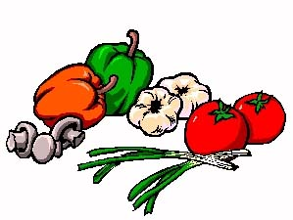
KISS ME

I’M VEGETARIAN

